**Experiment No. 10**

**Aim:** a) Create an application that will create database to store username and password.

b) Create an application to insert, update and delete a record from the database.

**Program:**

* **Activity.xml :-**

*<?*xml version="1.0" encoding="utf-8"*?>*<LinearLayout xmlns:android="http://schemas.android.com/apk/res/android"  
 xmlns:app="http://schemas.android.com/apk/res-auto"  
 xmlns:tools="http://schemas.android.com/tools"  
 android:layout_width="match_parent"  
 android:layout_height="match_parent"  
 android:orientation="vertical"  
 tools:context=".MainActivity">  
  
 <EditText  
 android:layout_width="match_parent"  
 android:layout_height="wrap_content"  
 android:id="@+id/et1"  
 android:gravity="center"  
 android:hint="Enter ID"/>  
 <EditText  
 android:layout_width="match_parent"  
 android:layout_height="wrap_content"  
 android:id="@+id/et2"  
 android:gravity="center"  
 android:hint="Enter Username"/>  
 <EditText  
 android:layout_width="match_parent"  
 android:layout_height="wrap_content"  
 android:id="@+id/et3"  
 android:gravity="center"  
 android:inputType="textPassword"  
 android:hint="Enter Password"/>  
 <LinearLayout  
 android:layout_width="wrap_content"  
 android:layout_height="wrap_content"  
 android:orientation="horizontal">  
 <Button  
 android:layout_width="wrap_content"  
 android:layout_height="wrap_content"  
 android:id="@+id/bt1"  
 android:text="INSERT"  
 android:onClick="InsertData"  
 android:layout_marginLeft="30dp"/>  
 <Button  
 android:layout_width="wrap_content"  
 android:layout_height="wrap_content"  
 android:id="@+id/bt2"  
 android:text="DELETE"  
 android:onClick="DeleteData"  
 android:layout_marginLeft="30dp"/>  
 <Button  
 android:layout_width="wrap_content"  
 android:layout_height="wrap_content"  
 android:id="@+id/bt3"  
 android:text="UPDATE"  
 android:onClick="UpdateData"  
 android:layout_marginLeft="30dp"/>  
 </LinearLayout>  
  
</LinearLayout>

* **MainActivity.java :-**

package com.example.sqlite;  
  
import androidx.appcompat.app.AppCompatActivity;  
  
import android.content.ContentValues;  
import android.database.sqlite.SQLiteDatabase;  
import android.database.sqlite.SQLiteOpenHelper;  
import android.os.Bundle;  
import android.view.View;  
import android.widget.Button;  
import android.widget.EditText;  
import android.widget.Toast;  
  
public class MainActivity extends AppCompatActivity {  
EditText et1, et2, et3;  
Button bt1, bt2, bt3;  
String uid, uname, upass;  
SQLiteDatabase db;  
SQLiteOpenHelper helper;  
 @Override  
 protected void onCreate(Bundle savedInstanceState) {  
 super.onCreate(savedInstanceState);  
 setContentView(R.layout.*activity_main*);  
 et1= findViewById(R.id.*et1*);  
 et2= findViewById(R.id.*et2*);  
 et3= findViewById(R.id.*et3*);  
 bt1= findViewById(R.id.*bt1*);  
 bt2= findViewById(R.id.*bt2*);  
 bt3= findViewById(R.id.*bt3*);  
 helper= new DbHelper(this);  
 }  
  
  
 public void InsertData(View view) {  
 uid= et1.getText().toString();  
 uname= et2.getText().toString();  
 upass= et3.getText().toString();  
  
 db= helper.getWritableDatabase();  
 ContentValues values= new ContentValues();  
 values.put(DbHelper.*COL_1*, uid);  
 values.put(DbHelper.*COL_2*, uname);  
 values.put(DbHelper.*COL_3*, upass);  
  
 double result= db.insert(DbHelper.*TABLE_NAME*, null, values);  
 if(result==-1)  
 {  
 Toast.*makeText*(this, "Insertion failed", Toast.*LENGTH_SHORT*).show();  
 }  
 else {  
 Toast.*makeText*(this, "Insertion successful", Toast.*LENGTH_SHORT*).show();  
 }  
 }  
  
 public void DeleteData(View view) {  
 uid= et1.getText().toString();  
 uname= et2.getText().toString();  
 upass= et3.getText().toString();  
  
 db= helper.getWritableDatabase();  
 ContentValues values= new ContentValues();  
 values.put(DbHelper.*COL_1*, uid);  
 values.put(DbHelper.*COL_2*, uname);  
 values.put(DbHelper.*COL_3*, upass);  
  
 double result= db.delete(DbHelper.*TABLE_NAME*, DbHelper.*COL_1*+"=?",new String[]{uid});  
 if(result==-1)  
 {  
 Toast.*makeText*(this, "Deletion failed", Toast.*LENGTH_SHORT*).show();  
 }  
 else {  
 Toast.*makeText*(this, "Deletion successful", Toast.*LENGTH_SHORT*).show();  
 }  
 }  
  
 public void UpdateData(View view) {  
 uid= et1.getText().toString();  
 uname= et2.getText().toString();  
 upass= et3.getText().toString();  
  
 db= helper.getWritableDatabase();  
 ContentValues values= new ContentValues();  
 values.put(DbHelper.*COL_1*, uid);  
 values.put(DbHelper.*COL_2*, uname);  
 values.put(DbHelper.*COL_3*, upass);  
  
 double result= db.update(DbHelper.*TABLE_NAME*, values, DbHelper.*COL_1*+"=?", new String[]{uid});  
 if(result==-1)  
 {  
 Toast.*makeText*(this, "Updation failed", Toast.*LENGTH_SHORT*).show();  
 }  
 else {  
 Toast.*makeText*(this, "Updation successful", Toast.*LENGTH_SHORT*).show();  
 }  
 }  
}

* **DbHelper.java :-**

package com.example.sqlite;  
  
import android.content.Context;  
import android.database.sqlite.SQLiteDatabase;  
import android.database.sqlite.SQLiteOpenHelper;  
  
import androidx.annotation.Nullable;  
  
public class DbHelper extends SQLiteOpenHelper {  
 public static final String *DATABASE_NAME*= "USER_DATABASE";  
 public static final String *TABLE_NAME*= "USER_TABLE";  
  
 public static final String *COL_1*= "ID";  
 public static final String *COL_2*= "NAME";  
 public static final String *COL_3*= "PASSWORD";  
  
 public DbHelper(@Nullable Context context) {  
 super(context, *DATABASE_NAME*, null, 1);  
 }  
  
 @Override  
 public void onCreate(SQLiteDatabase db) {  
 db.execSQL("CREATE TABLE USER_TABLE(ID INTEGER PRIMARY KEY AUTOINCREMENT, NAME TEXT, PASSWORD TEXT)");  
 }  
  
 @Override  
 public void onUpgrade(SQLiteDatabase db, int i, int i1) {  
 db.execSQL("DROP TABLE IF EXISTS"+*TABLE_NAME*);  
 onCreate(db);  
 }  
}

**Output:**

* **Insert data:**

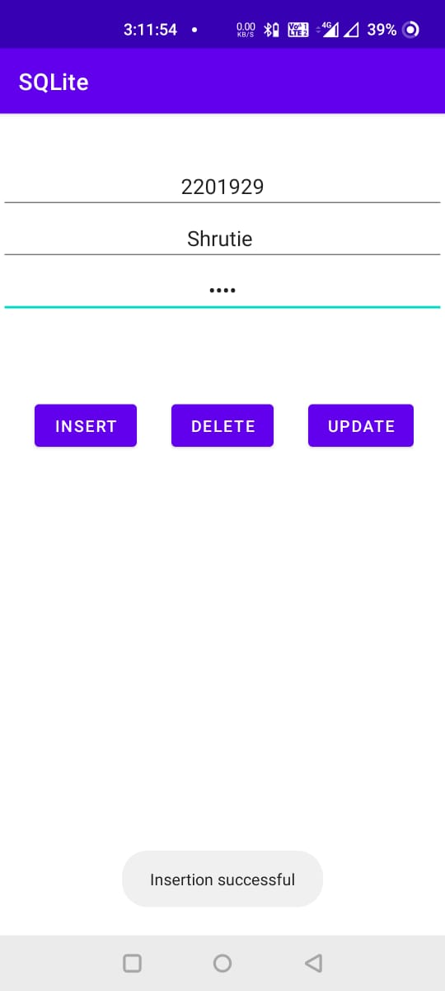

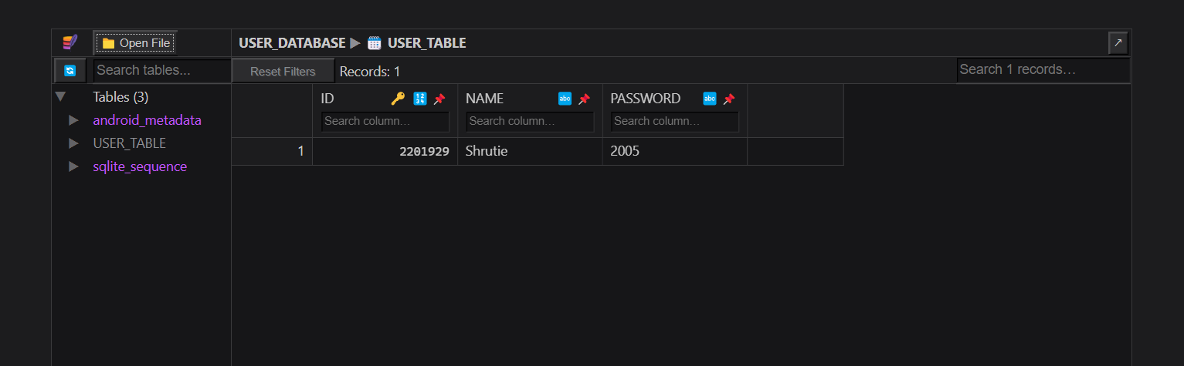

* **Update Data:**

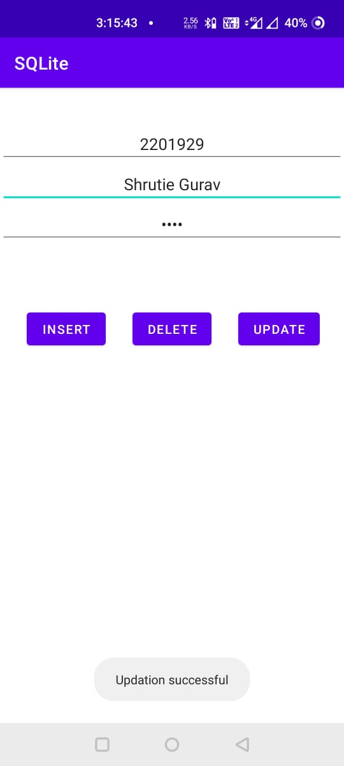

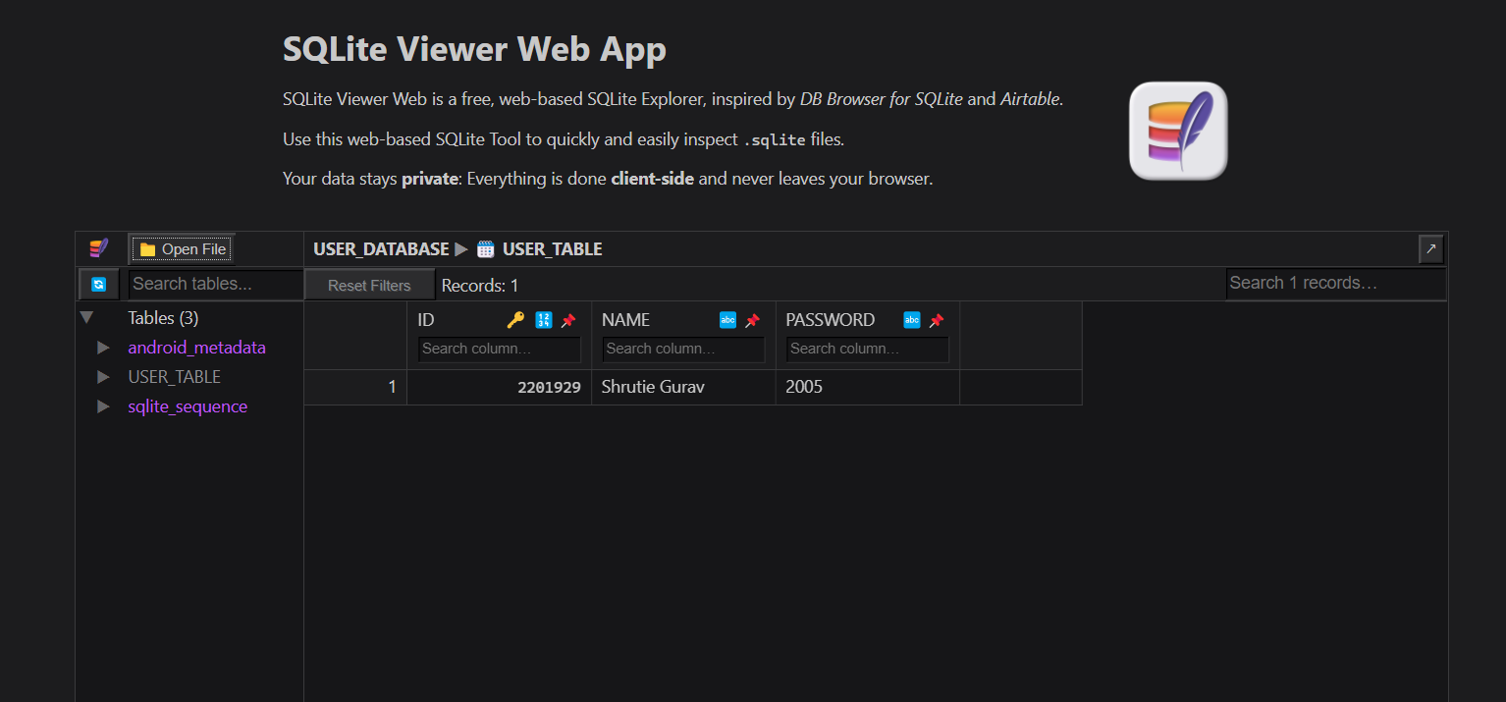

* **Delete Data:**

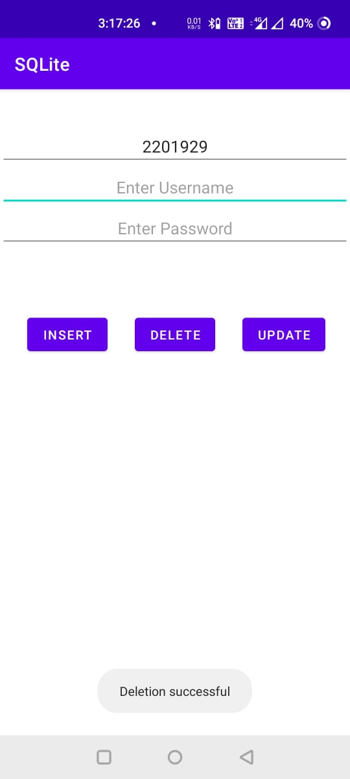

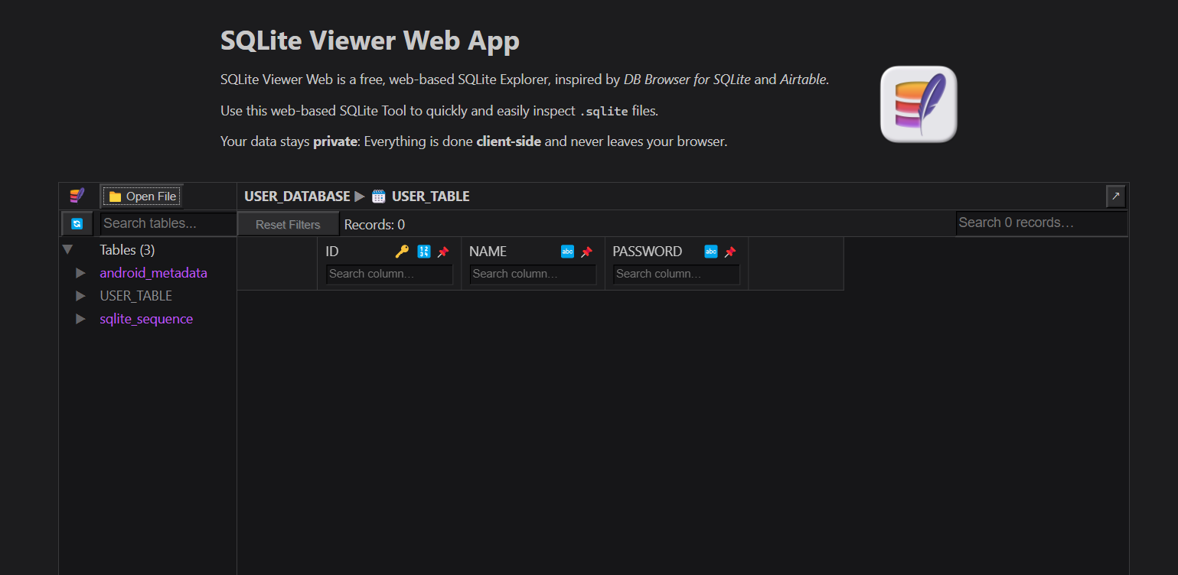



**Conclusion:**

Hence, by completing this experiment I came to know that how to Create a background application that will open activity on specific time.

|  |  |  |  |
| --- | --- | --- | --- |
| **Writeup & Oral**  **(4)** | **Practical Performance**  **(4)** | **Attendance**  **(2)** | **Total**  **(10)** |
|  |  |  |  |